**Ideation Phase**

**Define the Problem Statements**

|  |  |
| --- | --- |
| Date | 13 june 2025 |
| Team ID | LTVIP2025TMID32074 |
| Project Name | Sustainable Smart City Assistant using IBM Granite llm. |
| Maximum Marks | 2 Marks |

**Define the Problem Statements**

**Objective:**  
Create problem statements from the customer’s perspective. This helps your team focus on what truly matters and build solutions people will love.

A well-crafted problem statement allows your team to:

* Empathize with customers
* Identify real pain points
* Stay aligned on the solution vision

**Example:**

**Example:**

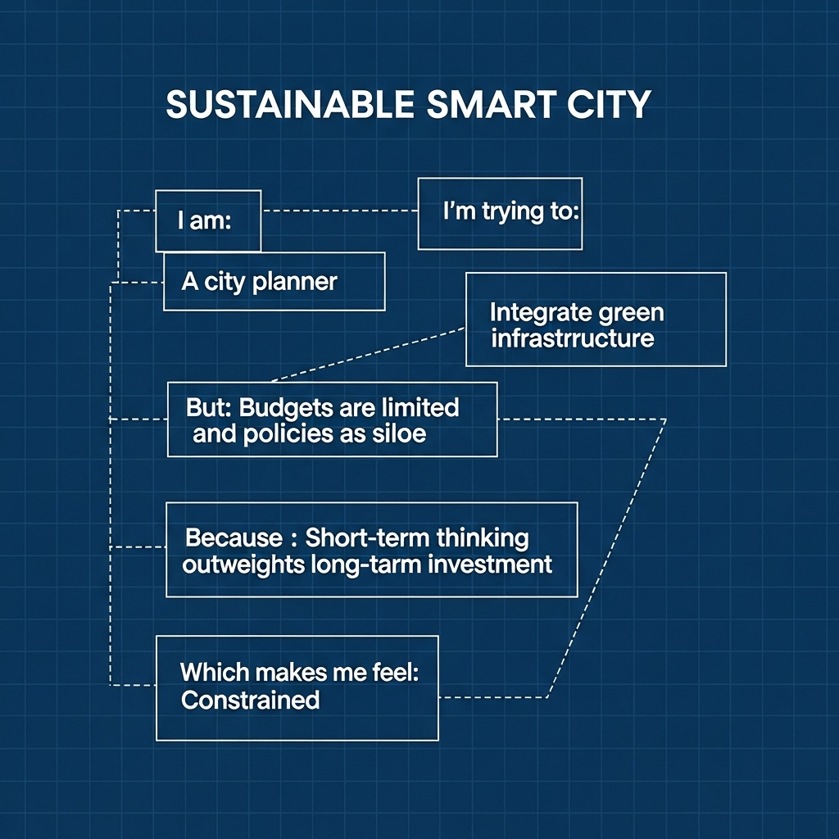

|  |  |  |
| --- | --- | --- |
| Field | PS-1 | PS-2 |
| I am | A city resident | An environmentally conscious citizen |
| I’m trying to | Report a garbage collection issue in my neighborhood | Track my home’s water and energy usage |
| But | I can’t find an accessible platform to do it | I don’t have access to real-time data or suggestions |
| Because | The city’s complaint portal is outdated and slow | There is no unified smart dashboard for my utilities |
| Which makes me feel | Frustrated and helpless | Disconnected from my sustainability goals |